Name: Nguyễn Văn Hải
Staff code: SD5975
- Setup
Before doing this assignment you need to install AWS CLI, Terraform:
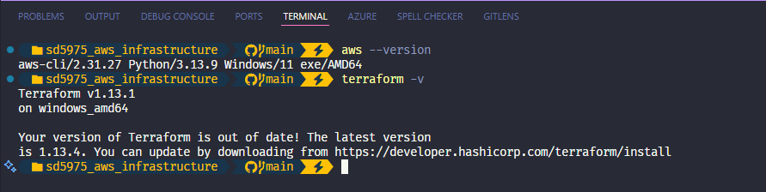
Install kubectl:
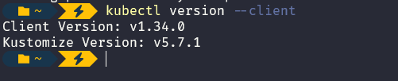
- Init terraform
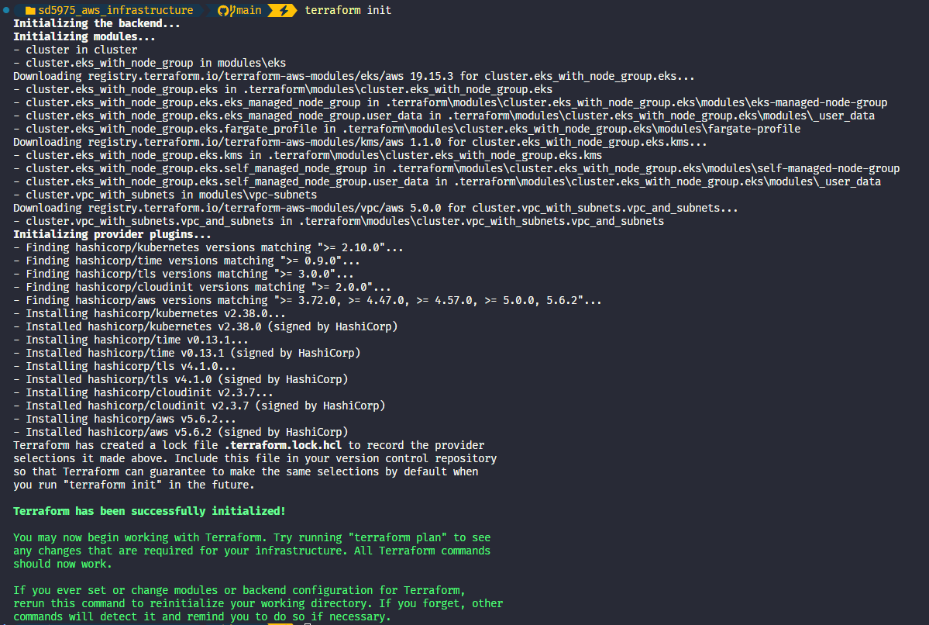
- Terraform plan
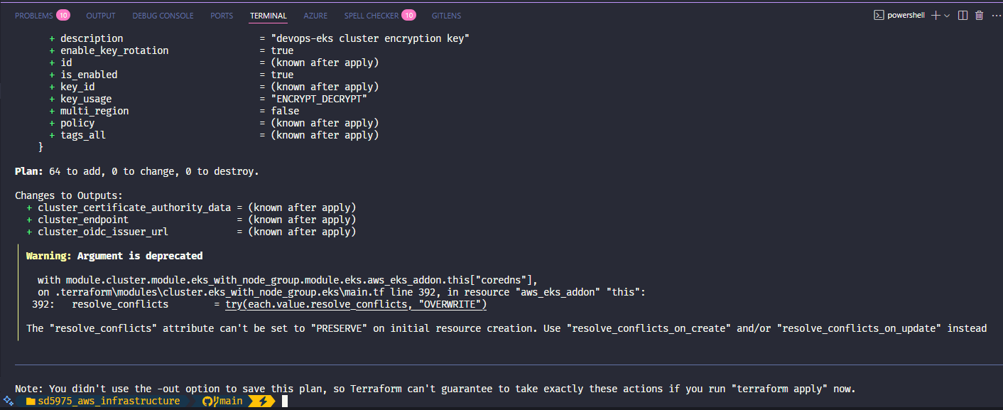
Then apply:
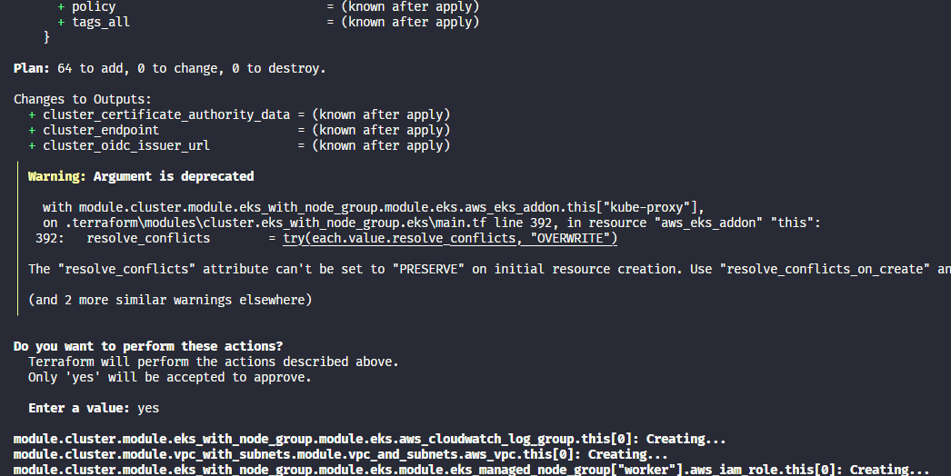
- Create and deploy
Navigate to devops-eks cluster then click to Get More add-ons
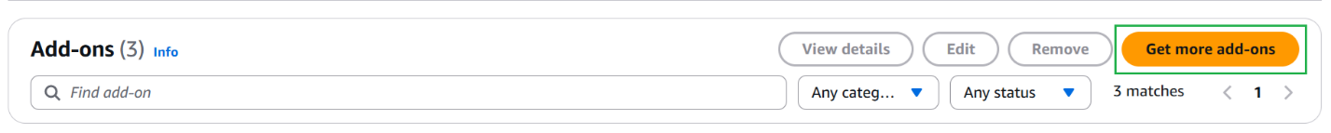
Then chose EBS CSI Driver.

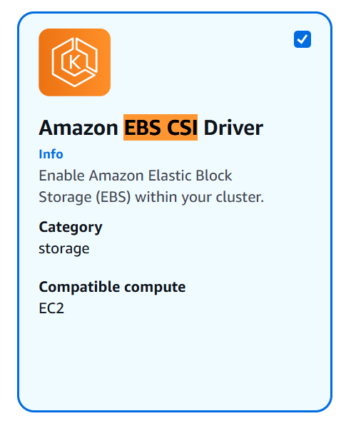
Then next, on the Add permissions step, the appropriate managed policy for the role policy is preselected for the add-on
AmazonEBSCSIDriverPolicy is selected as default
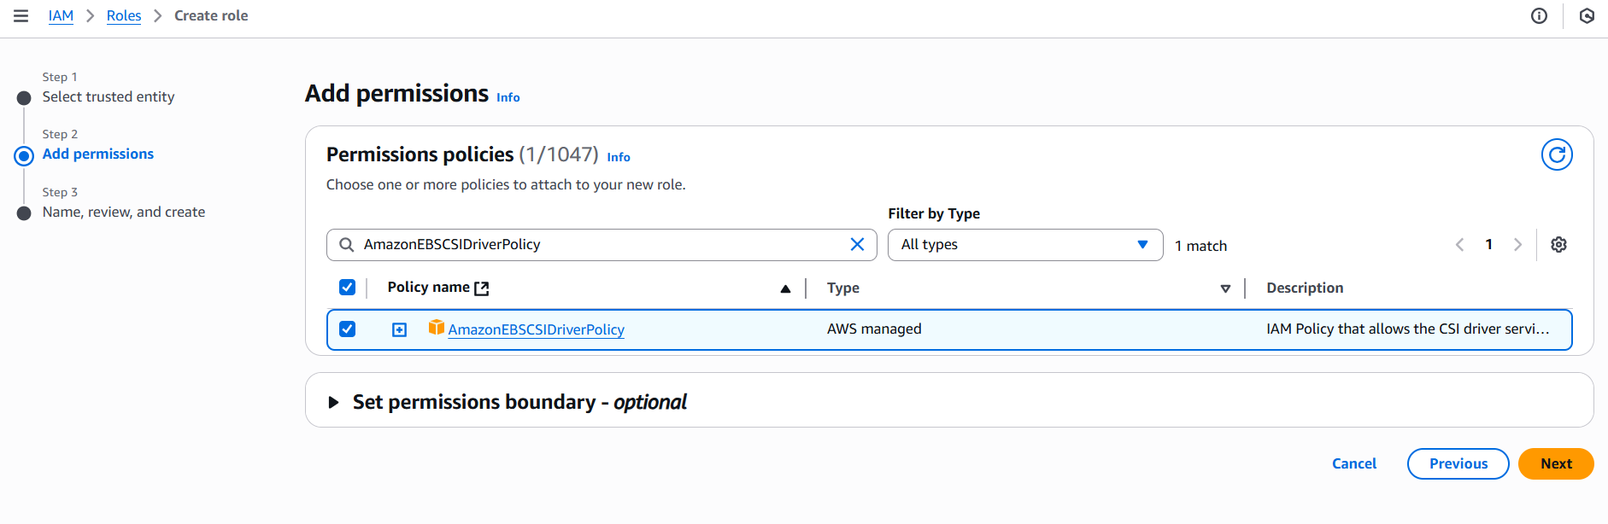
Then next => create role.
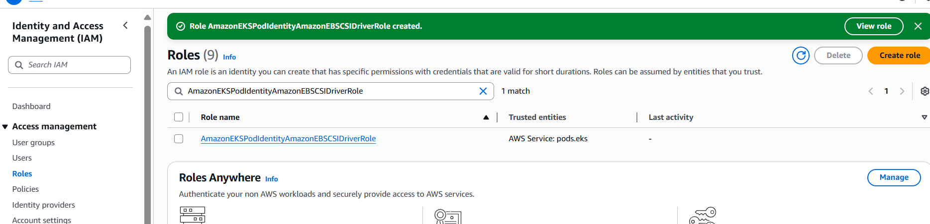
Result:
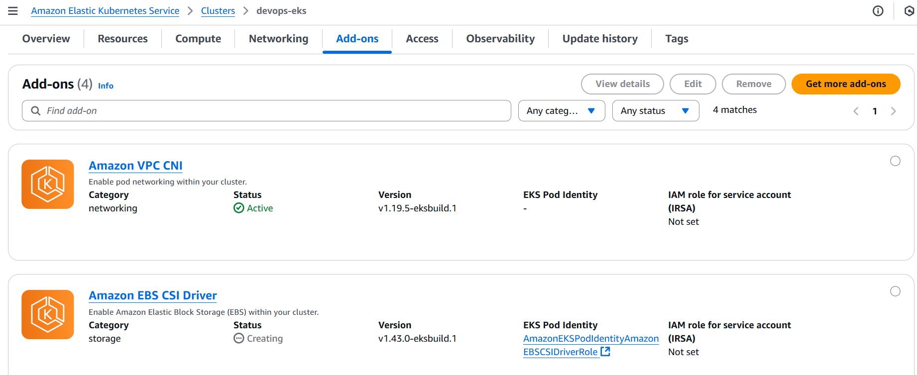
Back to terminal to deploy application in cluster

Deploy application:

aws eks update-kubeconfig --name devops-eks --region ap-southeast-1 --profile devops
kubectl create ns eks-ns
kubectl config set-context --current --namespace eks-ns
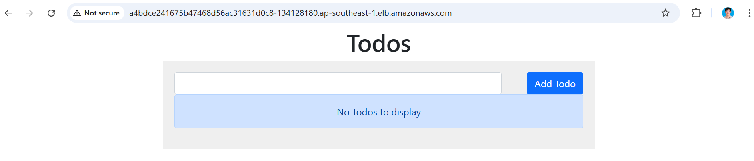
- Destroy
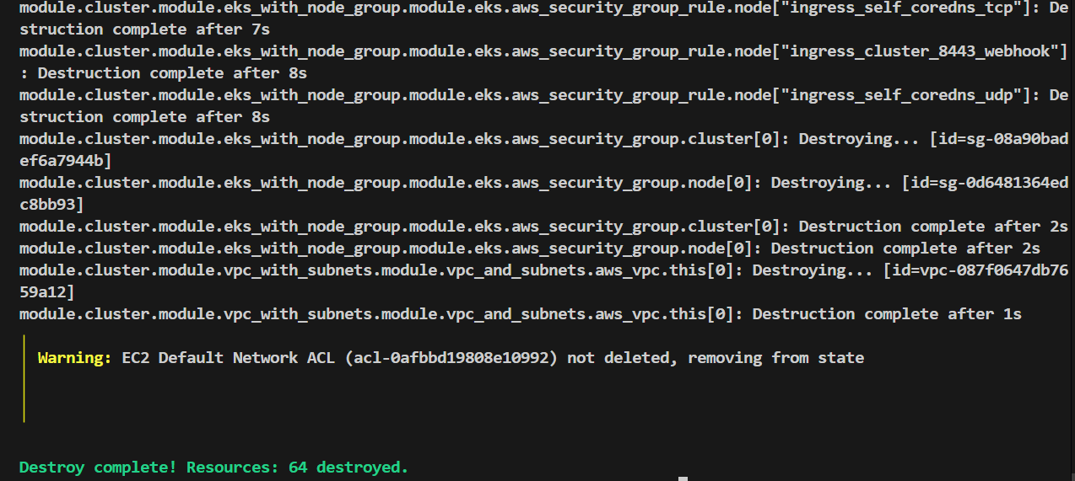
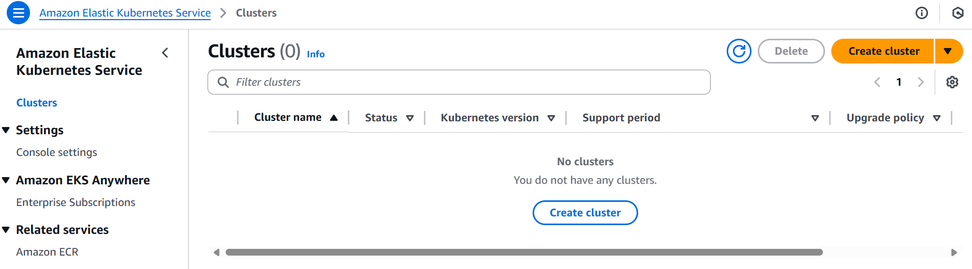
- Setup Jenkin & docker in EC2
Create an instance:
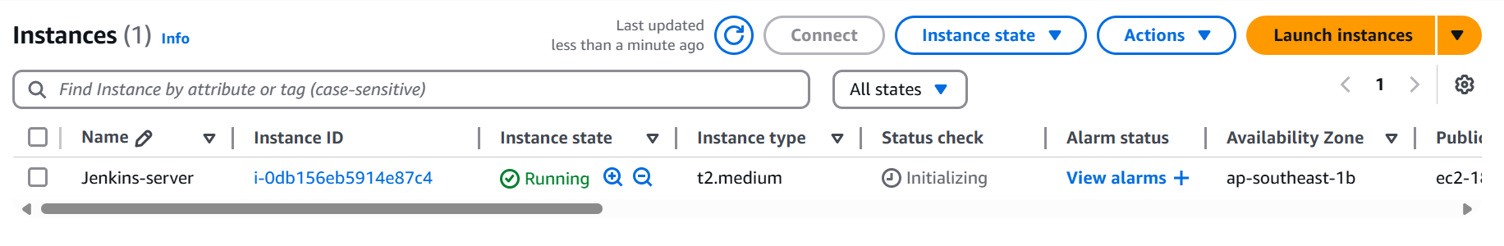
Setting allowing access to Jenkins-server
# click Security groups link of EC2
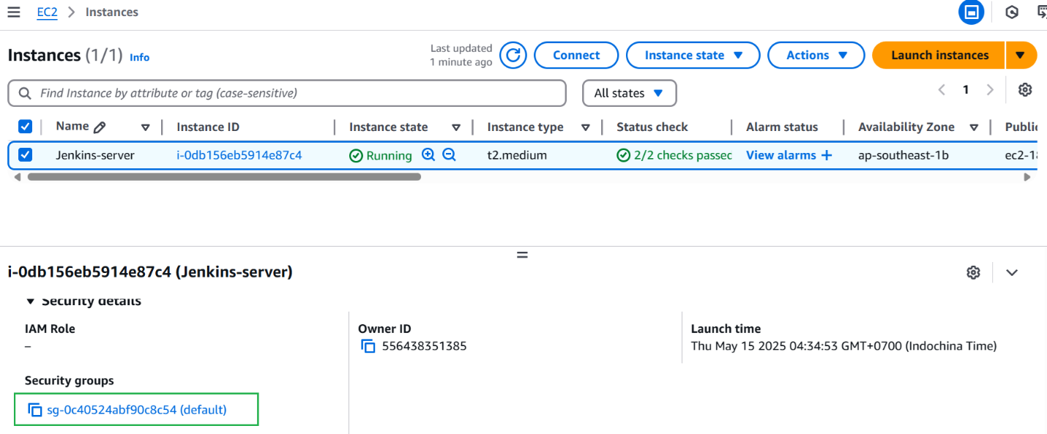
# click Edit inbound rules
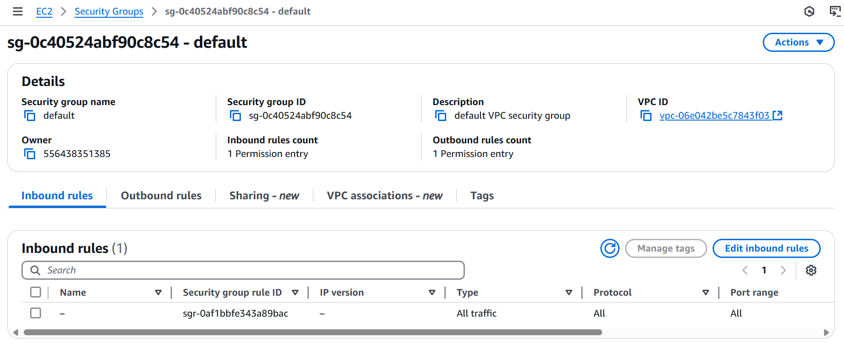
# add SSH rule as below => Click Save rules
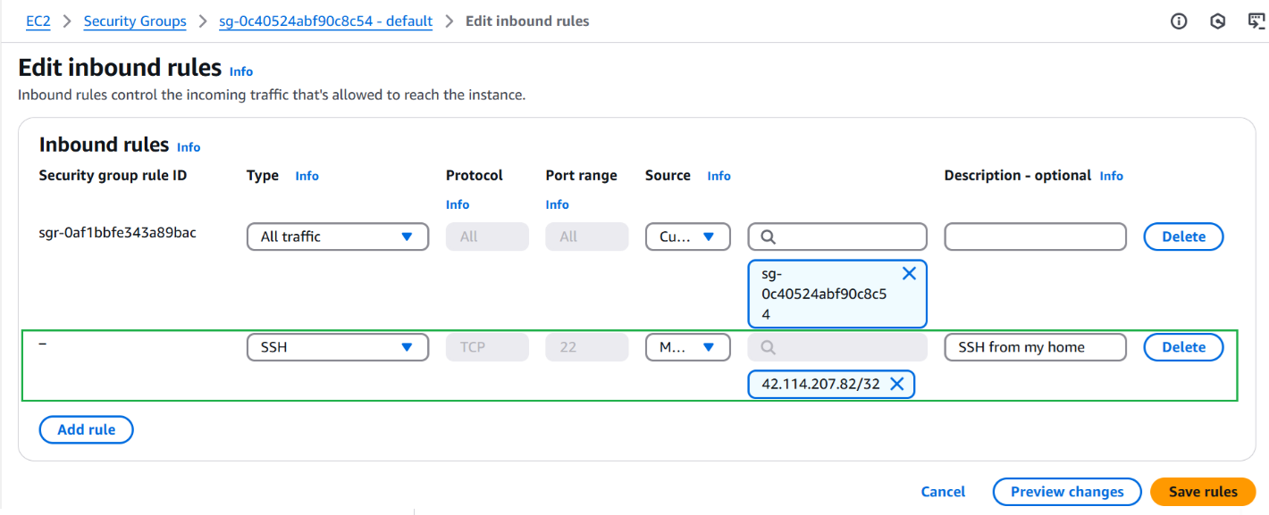
# add TCP rule to allow TCP port 8080 (8080 is default port of Jenkins)

Login to newly created EC2 to install Jenkins and Docker
# click checkbox in first column => Connect
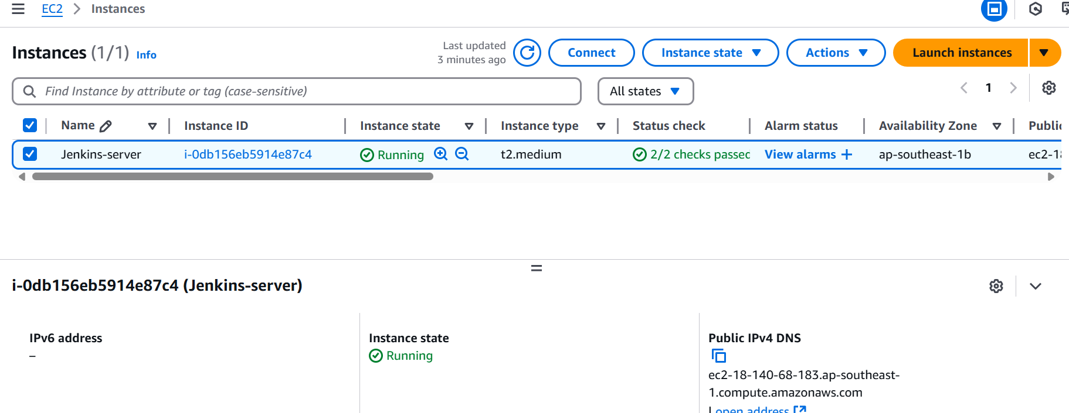
# click SSH client then follow the instruction to connect
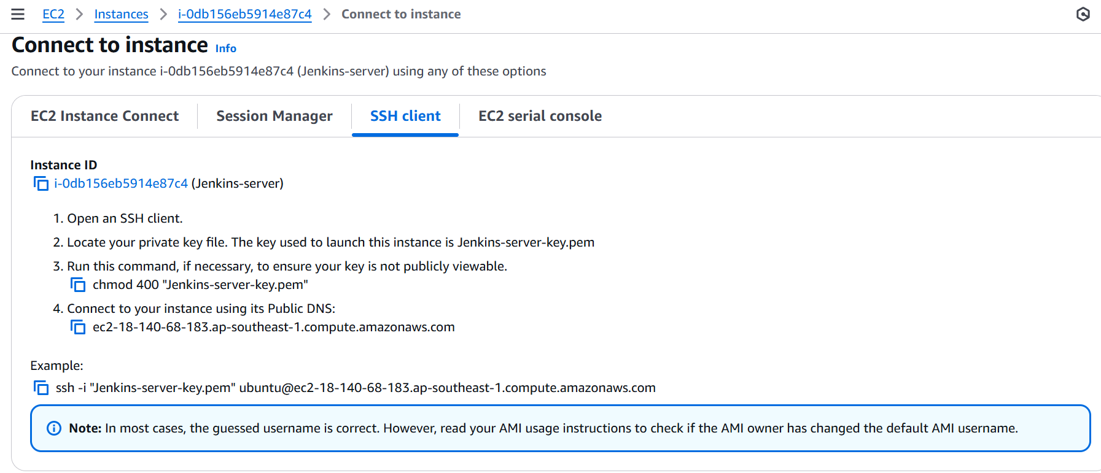
Connect with terminal and install jenkins by cli:
curl -fsSL https://pkg.jenkins.io/debian-stable/jenkins.io-2023.key | sudo tee \
/usr/share/keyrings/jenkins-keyring.asc > /dev/null
echo deb [signed-by=/usr/share/keyrings/jenkins-keyring.asc] \
https://pkg.jenkins.io/debian-stable binary/ | sudo tee \
/etc/apt/sources.list.d/jenkins.list > /dev/null
sudo apt-get update
sudo apt-get install jenkins –y
Result:
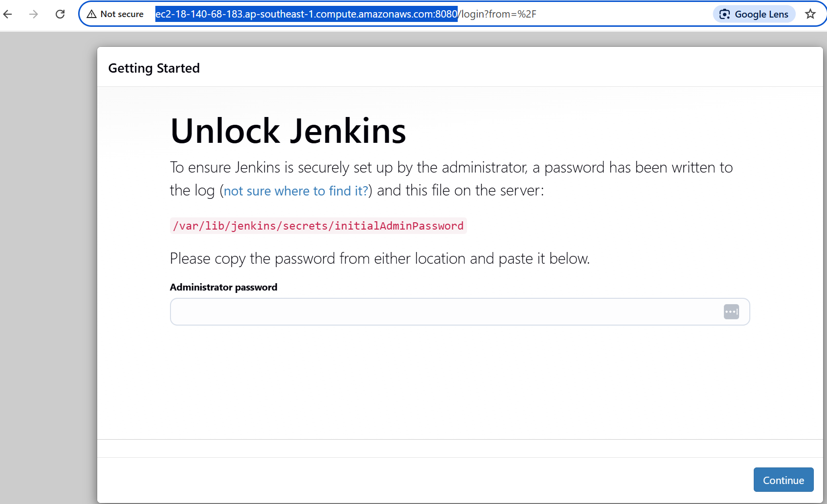
Install Docker:
sudo apt-get update
sudo apt-get install ca-certificates curl gnupg
sudo install -m 0755 -d /etc/apt/keyrings
curl -fsSL https://download.docker.com/linux/ubuntu/gpg | sudo gpg --dearmor -o /etc/apt/keyrings/docker.gpg
sudo chmod a+r /etc/apt/keyrings/docker.gpg
sudo apt-get install docker-ce docker-ce-cli containerd.io docker-buildx-plugin docker-compose-plugin
# check docker version
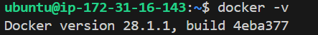
# check docker compose version
Install git
sudo apt-get install git-all

Install Trivy
sudo apt-get install wget apt-transport-https gnupg lsb-release
wget -qO - https://aquasecurity.github.io/trivy-repo/deb/public.key | sudo apt-key add -
echo deb https://aquasecurity.github.io/trivy-repo/deb $(lsb_release -sc) main | sudo tee -a /etc/apt/sources.list.d/trivy.list
sudo apt-get update
trivy --version

